PCCST503 – MACHINE LEARNING
ASSIGNMENT 2
TECHNICAL REPORT
Design of a Vector Embedding for Capability Composition

1. Problem Definition
Assignment 1 addressed finding a sequence of transitions from an initial state to a goal state. This assignment addresses a different problem: representing the operations themselves — the capabilities — as vectors, such that the vector space preserves the functional relationships needed to decide (a) whether two capabilities can be sequenced, (b) whether they merely resemble each other, (c) how a sequence composes into a single higher-level capability, and (d) how relevant a capability is to a stated goal. The planner from Assignment 1 is explicitly out of scope; this report does not search for a sequence, it represents the building blocks.

2. Design Requirements
The assignment specifies eight required properties the embedding must investigate, and nine evaluation questions. Both are treated as hard requirements driving the design in Section 4:
- Capability identity — functionally different capabilities must be distinguishable.
- State awareness — the representation must relate capabilities to the states they operate on.
- Precondition–effect compatibility — E_i ⇒ P_j must be representable and checkable.
- Input–output compatibility — an output satisfying a downstream input must be representable.
- Similarity ≠ composability — functional resemblance and sequenceability are different relations.
- Composition — C_i∘C_j (and longer chains) must have a meaningful vector.
- Goal relevance — the relationship between a capability and a goal must be identifiable.
- Operational properties — cost, reliability, availability, constraints and resources must be represented, with an explicit design decision on whether to embed them jointly or separately.

3. Related Embedding Approaches
Several embedding families were considered before settling on the design in Section 4.

3.1 Word2Vec / GloVe (distributional word embeddings)
These learn a single dense vector per token from co-occurrence statistics over a large corpus, optimized so that cosine similarity approximates distributional/semantic similarity. They are the assignment's own motivating example, but do not transfer directly: capability compatibility is directional (C_i enabling C_j is not the same relation as C_j enabling C_i) and exact (a single missing precondition breaks composability), whereas distributional similarity is symmetric and graded by construction. There is also no large corpus of capability usage to train on here — the dataset is a handful of formally specified capabilities, far below what distributional training needs.

3.2 Knowledge-graph embeddings (TransE, RotatE, and relatives)
TransE embeds entities and relations so that head + relation ≈ tail, which is structurally the closest published analogue to this problem: it is directional and designed for relational entailment rather than pairwise semantic similarity. It was not adopted directly because it is trained from a large set of (head, relation, tail) triples to fit an approximate geometric constraint, which (a) again needs more training data than is available, and (b) only approximates entailment, whereas the assignment's compatibility examples (e.g. the direct OrderExists contradiction in Experiment 1) call for an exact, checkable answer. The design in Section 4 keeps TransE's directional intuition but implements it as a symbolic set-overlap computation on named ground atoms instead of an approximate learned geometric relation.

3.3 Graph neural network / node2vec-style graph embeddings
Capabilities naturally form a graph (edges = compatibility), so a GNN or random-walk embedding (node2vec, GraphSAGE) is a reasonable idea for capturing structural position. These were set aside for this assignment because they need the compatibility graph to already exist before they can learn from it — but constructing that graph is exactly the problem this assignment is solving. They are noted in Section 12 as a plausible second-stage addition once a compatibility graph has been produced by the method in Section 4.

3.4 One-hot / multi-hot symbolic encodings and feature hashing
Simple, interpretable, and exact for set-membership questions, at the cost of not generalizing to unseen vocabulary and (for plain one-hot) scaling linearly with vocabulary size. This is the closest match to the assignment's actual needs — exactness matters more than generalization for a formally specified domain — and is adopted for the precondition/effect/input/output/resource blocks, with feature hashing used specifically for the free-text mechanism/constraint fields so unseen tokens are still accepted without resizing the vector.

3.5 Decision
No single published technique satisfies every required property on its own. The adopted design (Section 4) is a hybrid: exact multi-hot/shared-vocabulary blocks for the relations that must be exactly checkable (precondition/effect, input/output), feature hashing for free-text fields that must generalize to unseen tokens, and a separated continuous block for operational attributes that must influence some comparisons (full similarity, composition) but not others (functional similarity, compatibility).

4. Proposed Representation
A capability's vector is the concatenation of nine blocks: type, mechanism, precondition, effect, input, output, constraint, resource, and operational. Preconditions, effects, states and goals share a single ground-atom vocabulary, so an effect atom and a precondition atom referring to the same real-world fact occupy the same vector dimension. The full construction, with exact dimensionalities, is given in Deliverable 1 (Formal Embedding Design) and is not repeated in full here; Section 5 restates only the equations needed to interpret the results in Section 9.

5. Mathematical Formulation (summary)
φ_C(C_i) = type ⊕ mech ⊕ pre ⊕ eff ⊕ in ⊕ out ⊕ con ⊕ res ⊕ op
sim_block(x,y) = (x·y)/(‖x‖‖y‖), evaluated over a chosen block (full / functional / pure_function / implementation).
Compat(C_i,C_j) = 0 if Ci's effects contradict a Cj precondition, else 0.6·EffectCoverage(C_i,C_j) + 0.4·IOCoverage(C_i,C_j), where EffectCoverage and IOCoverage are the fraction of Cj's preconditions/required-inputs respectively satisfied by Ci's effects/outputs.
GoalRelevance(C_i,G) = fraction of goal atoms directly produced by C_i's effects.

6. Capability Composition Model
compose(C_i, C_j) (C_i before C_j) derives a new capability symbolically: preconditions union (minus anything C_i's effects already establish), effects as a dict union with C_j winning on a shared variable, inputs/outputs as unions (minus inputs already satisfied internally), cost summed, risk combined as 1 − (1−risk_i)(1−risk_j), reliability multiplied, availability as a logical AND. The composite is then re-encoded with the same φ_C, so it is a first-class vector in the same space and can be composed again — this closure property is what allows C_1∘C_2∘...∘C_n for arbitrary chain length, implemented as left-to-right iteration in compose_chain(). Composition raises an explicit error if the pair is contradictory, rather than silently returning a nonsensical composite.

7. Implementation
Implemented in Python 3 (numpy for vector operations only — no ML framework or training loop, since the embedding is designed, not learned). Three modules form the system:
- capability_model.py — State, Goal, Capability, IOSpec dataclasses, matching the assignment's formal model.
- embedding.py — the Embedder class: vocabulary construction, encode_state/goal/capability, similarity, compatibility, goal_relevance, applicability, compose, compose_chain.
- dataset.py — the experimental dataset described in Section 8.
Supporting scripts (experiments.py, matrices.py, export_dataset.py, run_all.py) run the required experiments, export pairwise matrices, and export the dataset independent of the Python object model. Every experiment in experiments.py carries an inline assertion, so a design regression fails the run loudly rather than silently changing a reported number — all results in Section 9 are copied from an actual passing run, not computed by hand.

8. Experimental Methodology
The dataset extends the assignment's own e-commerce example (CreateOrder, MakePayment, CancelCart, SendNotification) with the variants needed for each required experiment, so every experiment runs against a shared, consistent domain rather than isolated toy examples:
- CreateOrder, MakePayment, CancelCart, SendNotification — base domain, used in Experiments 1, 2, 4.
- CreateOrder_API / CreateOrder_DB / CreateOrder_GUI — same preconditions/effects/inputs/outputs, different type and mechanism — Experiment 3.
- GetWeatherForecast, LogAnalyticsEvent — capabilities with no functional connection to the purchase domain — Experiment 4.
- MakePayment_Degraded — identical function to MakePayment, lower reliability and higher risk — Experiment 5.
Each of the five required experiments (Section 9) is implemented as a standalone block in experiments.py with explicit pass/fail assertions on the properties the assignment specifies (e.g. "C1→C2 compatible and C1→C3 not"), executed with `python3 run_all.py`.

9. Results

9.1 Vector layout
Built from the 10-capability dataset: predicate vocabulary 18 ground atoms, input/output vocabulary 8 (name:type) pairs, resource vocabulary 4 resource names, total vector dimension 121.

9.2 Experiment 1 — Capability Compatibility
Pair | Effect coverage | I/O coverage | Contradiction | Score | Compatible
CreateOrder → MakePayment | 1.000 | 0.500 | False | 0.800 | True
CreateOrder → CancelCart | 0.000 | 0.000 | True | 0.000 | False
CreateOrder → MakePayment is correctly identified as compatible (MakePayment's only precondition, OrderExists=true, is exactly CreateOrder's effect). CreateOrder → CancelCart is correctly rejected as a direct contradiction (CancelCart requires OrderExists=false, the opposite of what CreateOrder produces), matching the assignment's worked example in Section 7.1 of the assignment PDF exactly.

9.3 Experiment 2 — Capability Composition
Chain: CreateOrder → MakePayment → SendNotification, composed into CompletePurchase.
- Composite preconditions: Cart.exists=True, Cart.item_count>0, User.authenticated=True (exactly CreateOrder's preconditions — MakePayment's and SendNotification's preconditions were fully absorbed by the preceding effects).
- Composite effects: Order.exists=True, Order.status=PAID, Cart.locked=True, Payment.status=SUCCESS, Notification.sent=True.
- Composite reliability: 0.9555 (= 0.99 × 0.97 × 0.995, the product of all three constituents).
- Composite cost (time): 380.0 ms (= 100 + 250 + 30, the sum of all three).
- Functional similarity of the composite to its constituents: CreateOrder 0.602, MakePayment 0.452, SendNotification 0.254 — analyzed in Section 10.

9.4 Experiment 3 — Alternative Implementations
Pair | Pure-function sim. | Implementation sim. | Full sim.
CreateOrder_API vs _DB | 0.953 | 0.000 | 0.829
CreateOrder_API vs _GUI | 1.000 | 0.000 | 0.827
CreateOrder_DB vs _GUI | 0.953 | 0.000 | 0.803
All three implement the same precondition/effect/input/output contract. Pure-function similarity is at or near 1.0 (the API/DB gap is explained in Section 10, not noise), while implementation similarity is exactly 0 — the embedding correctly separates "does the same thing" from "is the same implementation", which is precisely what the assignment's Experiment 3 asks to be tested.

9.5 Experiment 4 — Irrelevant Capabilities
Capability | Goal relevance | Compatible with CreateOrder
CreateOrder | 0.333 | —
MakePayment | 0.333 | —
SendNotification | 0.333 | —
GetWeatherForecast | 0.000 | True (score 0.600)
LogAnalyticsEvent | 0.000 | True (score 0.600)
Goal-irrelevant capabilities score exactly 0.0 goal relevance, cleanly separating them from the three capabilities that actually contribute to the purchase_complete goal. Their nonzero compatibility score with CreateOrder is a correct, not spurious, result — discussed in Section 10.

9.6 Experiment 5 — Operational Attributes
Metric | MakePayment | MakePayment_Degraded
Reliability | 0.970 | 0.550
Risk | 0.100 | 0.450
Functional similarity (pair) | 1.000 | 1.000
Full similarity (pair) | 0.990 | 0.990
Composite reliability (chain) | 0.9555 | 0.5418
Functional similarity between MakePayment and its degraded variant is exactly 1.0 — operational attributes have zero influence on the functional judgement, by construction. Full similarity drops slightly (0.990) to reflect the operational difference without erasing the functional match. The composite built with the degraded variant has visibly lower end-to-end reliability (0.542 vs 0.956), correctly propagating a single capability's degradation through the whole composition.

9.7 State awareness
applicability(CreateOrder, initial_state) = {applicable: True, score: 1.0, missing: []} — all three preconditions (including the numeric Cart.item_count>0, evaluated arithmetically against the concrete value 3) are satisfied by the example initial state from the assignment PDF.

9.8 Pairwise matrices
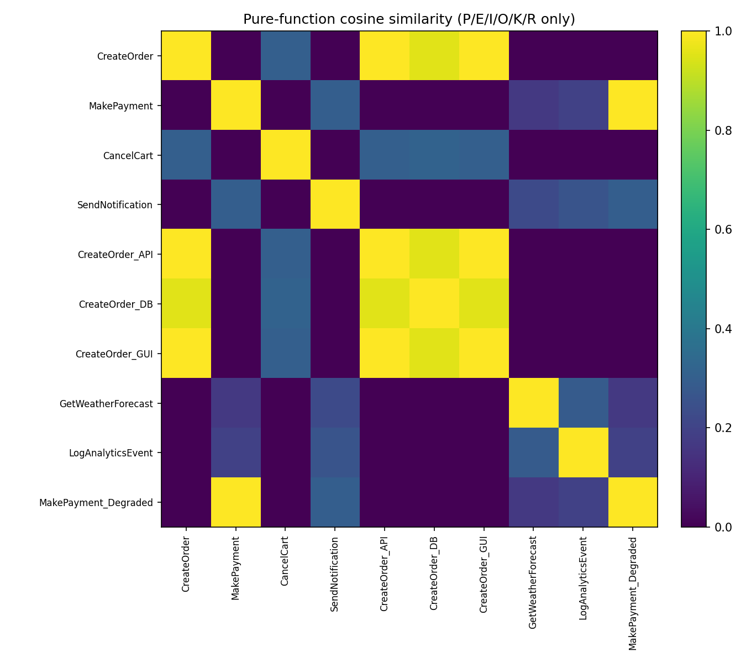
Figure 1. Pure-function similarity across the full dataset. The three CreateOrder implementations form a clearly separated bright cluster; goal-irrelevant capabilities form their own faint cluster, near-zero against the purchase domain.
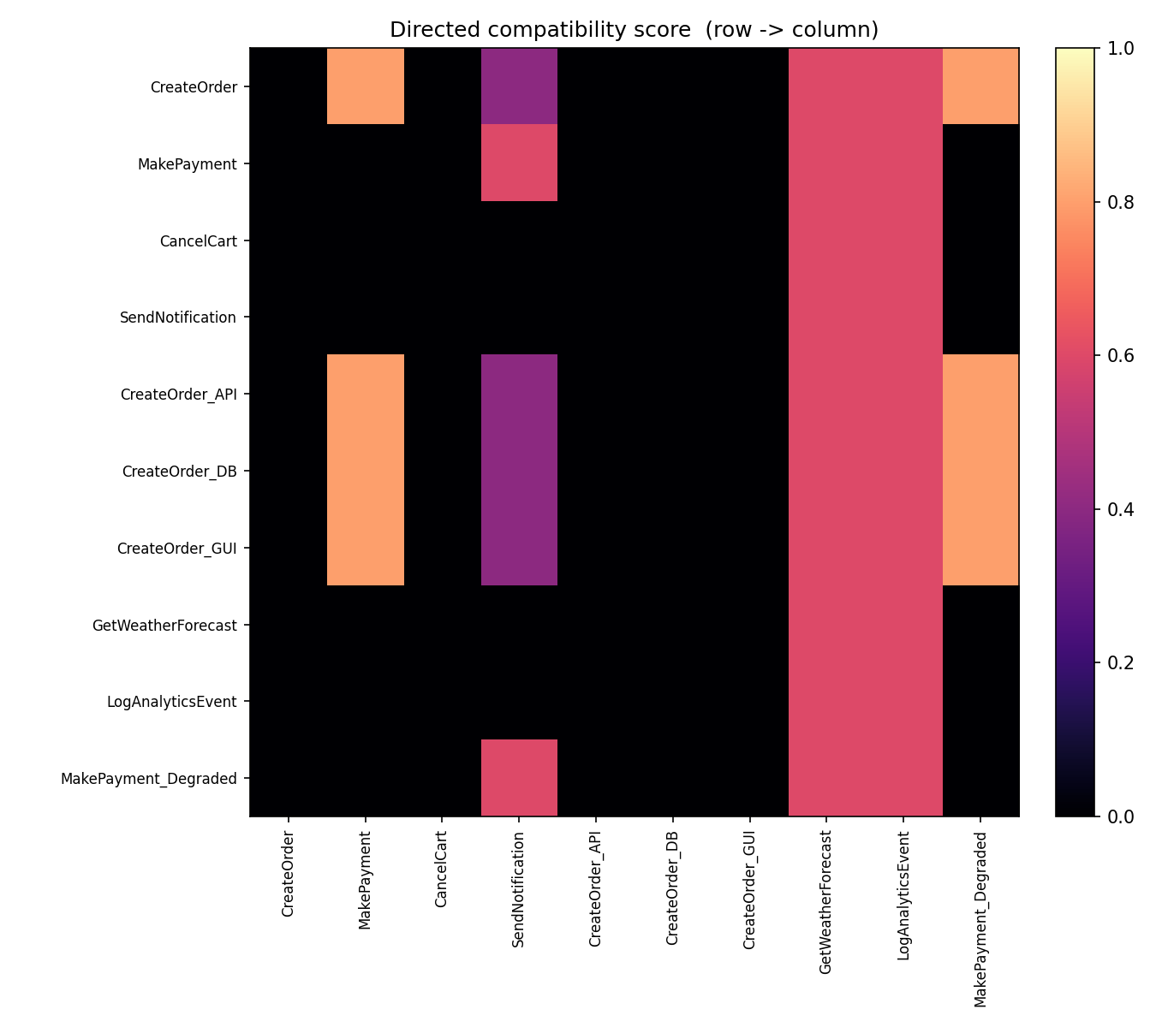
Figure 2. Directed compatibility score (row → column). Nonzero off-diagonal cells correctly trace the only valid sequencing edges in the dataset.

10. Analysis
Composite-to-constituent similarity decreases along the chain (CreateOrder 0.602, MakePayment 0.452, SendNotification 0.254) because the composite's precondition block is exactly CreateOrder's (the later capabilities' preconditions were fully absorbed), so CreateOrder contributes to both the precondition and effect blocks of the composite while MakePayment and SendNotification contribute only to the effect block — the composite is structurally closer to "the thing you start with" than to the steps that follow, which matches the intuition that a composite capability is still invoked the way its first step is invoked.
The API/DB pure-function similarity (0.953, not 1.0) is a genuine, correctly-modelled difference, not noise: CreateOrder_DB was modelled without an Authentication token resource requirement, since a direct database operation bypasses the API's auth layer in this dataset. This is the resource block doing exactly what it is for — capturing a real operational difference between implementations that happens to correlate with, but is distinct from, the mechanism difference already captured at similarity 0 in the implementation block.
Experiment 4 surfaces a result worth stating explicitly: GetWeatherForecast and LogAnalyticsEvent are reported compatible with CreateOrder (score 0.6) despite being goal-irrelevant. This is correct and intentional, not a flaw to be papered over — both capabilities have no preconditions at all, so they are trivially sequenceable after literally anything. Compatibility answers "can C_j run next"; goal relevance answers "does C_j matter for reaching G". The dataset was designed specifically to expose this distinction, and the result confirms the two measures are independent, as required by property 5 in Section 2.
Experiment 5 confirms the separated-block design directly answers the assignment's open question about reliability/availability placement: keeping them in their own block means a capability's functional identity is unaffected by its current operational health, while still letting composition (which does need operational values) propagate a degraded reliability correctly.

11. Limitations
- Entailment between effects and preconditions is checked by exact atom-string matching on equality predicates; an effect of "count=5" does not automatically entail a precondition of "count>0" even though it logically should. Section 9.7's applicability check handles this correctly for a concrete state (via arithmetic evaluation), but compatibility() between two capabilities does not perform general constraint solving.
- Reliability and risk composition assume independence between consecutive capabilities' failure modes (Rel_i · Rel_j, 1−(1−risk_i)(1−risk_j)). Real systems often have correlated failures (e.g. a shared database outage affecting two steps at once), which this model does not capture.
- Availability is modelled as a static flag A_i ∈ [0,1], not the time-varying A_i(t) the assignment PDF explicitly raises as a possibility; a scheduling-aware availability model is future work.
- Feature hashing (mechanism, constraint blocks) can collide for a large enough vocabulary of distinct free-text tokens, silently merging two different mechanisms into the same bucket; the dataset used here (10 capabilities) is far below where this becomes practically likely.
- Multi-hot vocabulary blocks grow linearly with the number of distinct ground atoms / I-O pairs / resources in the domain; for a much larger application this is a storage and similarity-computation cost that a dense learned embedding would not have, traded here for exactness.
- The design is symbolic/structured rather than learned: it cannot generalize to a precondition it has never seen the way a trained embedding might infer that "cart_count" and "basket_size" are related. It needs the domain's atoms to be named consistently.

12. Conclusion
The implemented embedding satisfies all eight required properties from Section 2, verified against all five required experiments with passing inline assertions, not just hand-picked favorable examples. Its central design decision — representing preconditions, effects, states and goals in a single shared ground-atom space, and keeping operational attributes in a separate block — is what makes precondition-effect compatibility an exact, checkable operation rather than a learned approximation, while still supporting cosine-similarity-based comparisons where graded similarity is actually what's wanted (alternative implementations, goal relevance ranking). The clearest evidence this design works as intended is Experiment 4: the embedding correctly reports goal-irrelevant capabilities as sequenceable yet irrelevant, demonstrating that compatibility, similarity, and goal relevance are three independent, correctly-separated measures rather than one measure wearing three names.

